The 104th Pacific Coast Oto-Ophthalmological Society Meeting
Meeting Registration Form June 24 – 26, 2022
The Outrigger Waikiki Beach Resort, Honolulu, Hawaii
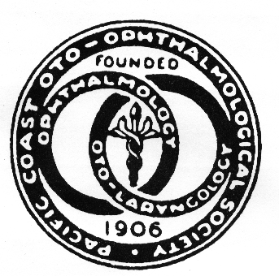  Additional Meals:  CONTINENTAL BREAKFAST  Friday, June 24 1 Ticket included with registration)  Additional Tickets:  Adults $41 .. #_______ $________  Child: $19 (5-11yrs) #_______ $________  Saturday, June 25(1 Ticket included with registration)  Additional Tickets:  Adult: $41 #_______ $_______  Child: $21 (5-ll yrs) #_______ $_______  Sunday, June 26 (1 Ticket included with registration)  Additional Tickets:  Adults $41 #_______ $________  Child: $21 (5-11yrs) #_______ $________  PRESIDENT’S Welcome Reception - Included  Friday, June 24 (1 Ticket included with meeting Registration).  *Please check if you plan to attend_____  Additional Tickets:  Adult : $79 # _______ $___________  Child: $$39 (5-11yrs) # _______ $ __________  Under 5 No charge if registered in advance  Guest Name/s and ages of children: _____________  ___________________________________________  Badges must be worn at all times  Please indicate any dietary restrictions:  _______________________________ | REGISTRATION  Please Print  NAME  ADDRESS  CITY STATE ZIP  PHONE:  E-MAIL (required – please print clearly)  ACADEMIC AFFILIATION or COMPANY  _____Ophthalmology or Otolaryngology ______  REGISTRATION By 2/28/22 By 4/15/22 By 6/15/22 On-Site  Physician Member Physician Non- Member $689 $829 $739 $869 $769 $899 $789 $919  PA/NP/RN/PhD $599 $649 $679 $699  Fellow/Residents $389 $429 $459 $479  Corporate Attendee $1,295 $1,395 $1,495 $1,550  Fully retired and over 65 – please contact Thelma for rate  Registration includes:  Continental breakfast and refreshment breaks daily, Friday reception,  Meeting Registration (above) $ _____________  Membership Dues: $99 active MDs only  Retired 65 & fully Retired: $25 optional $ _____________  Extra Meals (left panel) $ _____________  TOTAL $ _____________  If you have questions, please contact:  Thelma de Souza 415-269-0089  Email: Thelmades@aol.com  *Meeting Registration Cancellation if received by:  April 15, 2022 Payment minus $ 75 plus Paypal billing fee  May 15, 2022 Payment minus $350 plus Paypal billing fee  No Refunds after May 15, 2022  Membership cancellation  There is no refund issued for Membership cancellation

PACIFIC COAST
OTO-OPHTHALMOLOGICAL SOCIETY
- 17th Avenue
San Francisco, CA 94122
Email: Thelma.PCOOS@gmail.com: Website: WWW.PCOOS.ORG
Thelma de Souza, Society Manager, Phone: (415) 269-0089

2022 MEMBERSHIP Information

OPH___ OTO____ Sub-Specialty:______________________________

Name of Member: _____________________________________________________________

Affiliation: ___________________________________________________

Email (required):______________________________________________

Phone:__________________

Current Mailing Address: _______________________________________________________
_______________________________________________________ _______________________________________________________

Would you like to be listed in the PCOOS Directory? ___ YES ___ NO

Active Member: $99
Over 65 and Fully Retired: $25 Optional

Add late fee of $25 if not received postmarked by 4/15/22

Please pay dues with Meeting Registration or mail separately if you wish to renew membership but not planning to attend the 2022 meeting.

Make check payable to: PCOOS
Thelma deSouza
1681 17th Avenue
San Francisco, CA 94122

Thank you!

