Save the Date
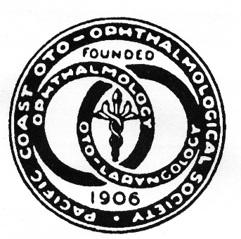
The 103rd annual scientific meeting of the
Pacific Coast Oto-Ophthalmological Society
June 21-23, 2019
Hyatt Regency Resort, Maui, Hawaii

17 AMA PRA Category 1 Credit(s)™
- Otolaryngology Updates:
Rhinology, Otology, Head & Neck, Plastics, Endocrine, Laryngology, Pediatrics
- Ophthalmology Updates:
Retina, Neuro-Ophthalmology, Cornea, Glaucoma, Pediatrics, Plastics, Uveitis
Discount room rates: $219 Resort View, $249 Golf/Mountain View, $279 Partial Ocean View, $299 Deluxe Ocean View
Discount resort, parking, & golf Fees. 24 hr Fitness center, Yoga, Internet, Spa, Tennis, resort & cultural activities. In room coffee, Resort shuttle, Wildlife
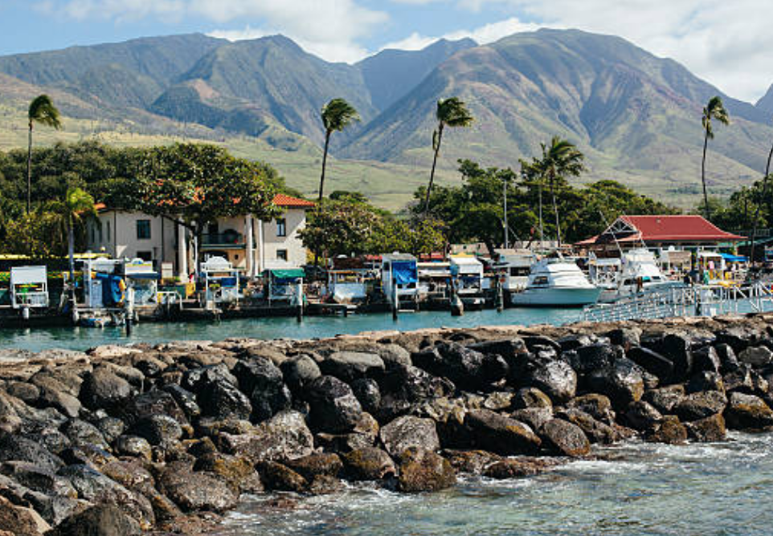 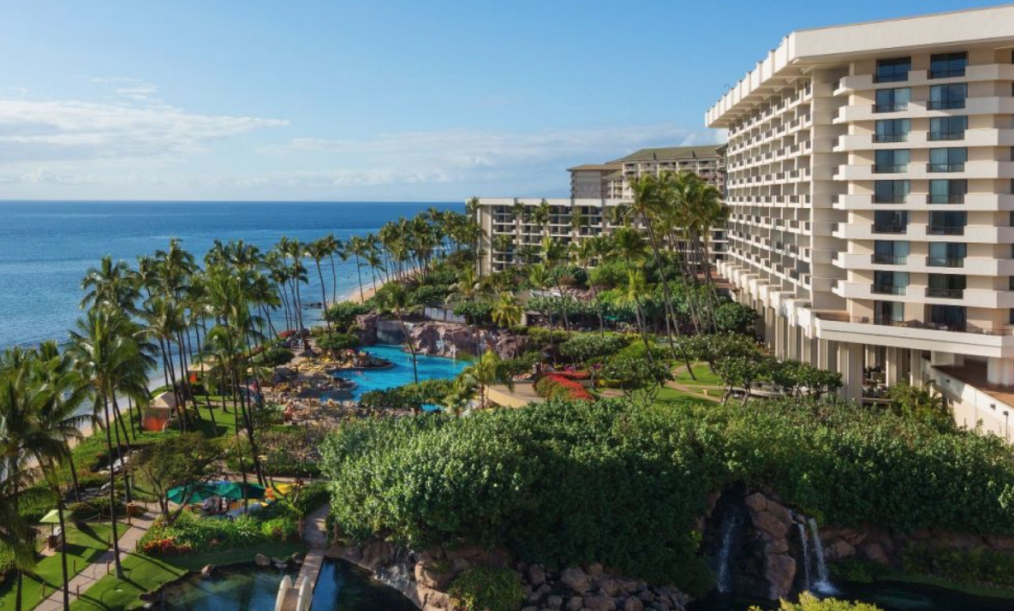 Information: Thelma de Souza Thelmades@aol.com 415-269-0089 WWW.PCOOS.org
Abstract submission deadline 01/31/19 Early Discount Registration deadline 02/28/19

