THE 101st PACIFIC COAST
OTOLARYNGOLOGICAL-OPHTHALMOLOGICAL SOCIETY MEETING
The Fairmont Orchid, Big Island, Hawaii
June 23-26, 2017

The Fairmont Orchid
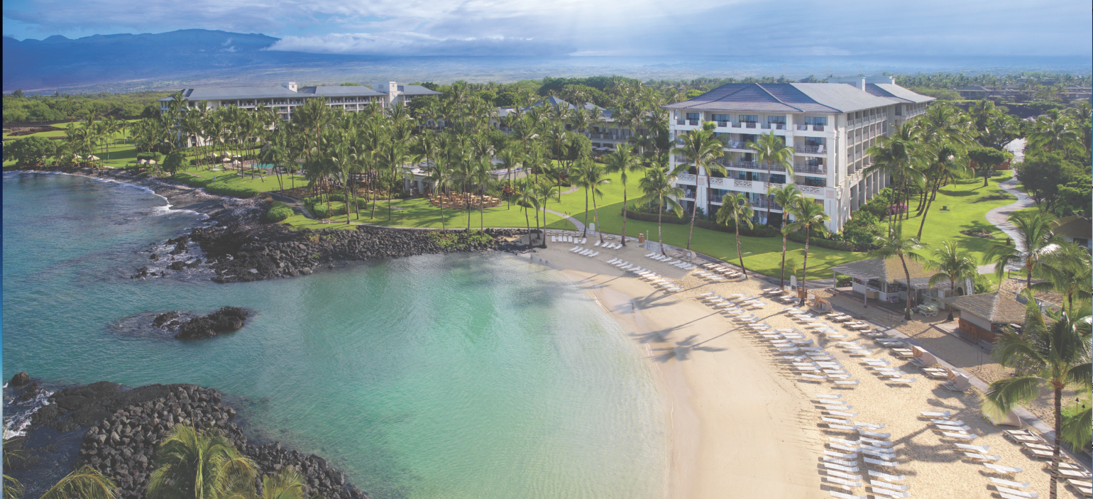
The Fairmont Orchid boasts luxurious accommodations on an expansive white sand beach
with beautifully landscaped grounds. Rooms are 540 sq feet with marble baths and lanais.

CME credits up to 21.00 hrs
Esteemed speakers covering clinical and scientific updates
in Otolaryngology and Ophthalmology
Friday Morning – Conjoint Session
Friday Afternoon – Otolaryngology Session
Saturday, Sunday, and Monday Mornings– Otolaryngology Sessions

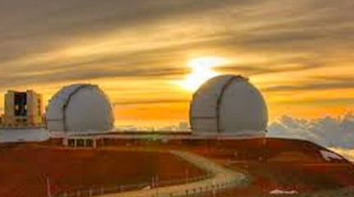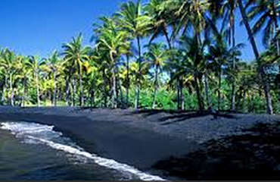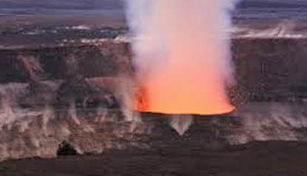

Big Island Attractions: Volcanoes National Park, City of Refuge Historic Park, Observatory
on Mauna Kea, Snorkel at Captain Cook Monument, numerous Farmer’s Markets, Coffee Plantations,
Botanical Garden in Hilo, Akaka Falls Park, Kailua-Kona, Black Sand Beaches

Call Thelma de Souza at 415-269-0089 or email: Thelma.PCOOS@gmail.com

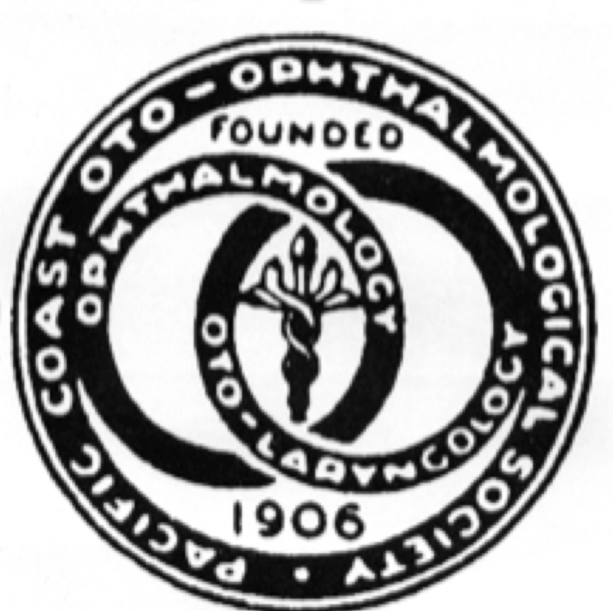

101st Pacific Coast Oto-Ophthalmological Society Meeting
June 23-26, 2017
Exhibitor/Commercial Support Application

Name of Company:_____________________________________________________
(as you would like it to appear on the program)
Company Representative:________________________________________________

Address:_____________________________________________________________

____________________________________________________________________
_
Email Address:______________________________Phone:_____________________

_____ We would like to participate as a Corporate Sponsor:
_____ $3,000-$5,000 (acknowledgement of primary support in our printed program and admission for one/two corporate attendees to the program)

_______We would like to participate as an Exhibitor/Supporter:
_______ Fee $5,000 – 4 Days (includes daily Breakfast & Breaks for two Exhibit staff and one corporate attendee), admission to the President’s welcome reception, plus first choice of booth location, acknowledgment of support in the printed program
______ Fee $3,000 - 4 Days (includes daily Breakfast & Breaks for two Exhibit staff, two 6’exhibit tables, primary exhibit location, attendance President’s welcome reception, choice of booth location, acknowledgement of support in the program
______ Fee $1,995 - 4 Days (includes daily Breakfast & Breaks for one Exhibit staff), One 6‘ Exhibit table. Acknowledgement of support in the printed program)

Signature:__________________________________ Date______________

PCOOS Non-Profit Tax ID Number: 95-6059535
Please send to: Thelma de Souza
(due April 30, 2017) 1681 17th Avenue, San Francisco, CA 94122
Make Check Payable to: Pacific Coast Oto-Ophthalmological Society
(due April 30, 2017)
For Information, please contact Thelma de Souza at 415:269-0089, Thelma.PCOOS@gmail.com

10/4/2016
Dear Potential Corporate Sponsor,

The Pacific Coast Otolaryngological-Ophthalmological Society’s membership is composed of board certified otolaryngologists and ophthalmologists from predominantly the thirteen western states. The membership includes physicians in these specialties.

We cordially invite you to join us at our 101st annual meeting at the Fairmont Orchid, Big Island, Hawaii as a corporate sponsor/exhibitor. There are approximately 200-300 participants (total) of ophthalmologists and otolaryngologists and would be an excellent venue to exhibit your product.

If interested, please contact our society coordinator Thelma de Souza at (415)269-0089, Thelma.PCOOS@gmail.com and fill out the attached exhibitor/commercial support application.

Sincerely,

Christopher Tang, MD FACS
Otolaryngology/Head and Neck Surgery
PCOOS Executive Council

