Save the Date
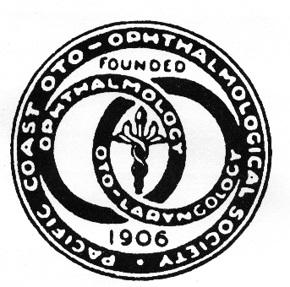
The 102nd annual scientific meeting of the
Pacific Coast Oto-Ophthalmological Society
June 22-24, 2018
Coeur d’Alene Resort, Idaho

- 17 AMA PRA Category 1 Credit(s)™
- Ophthalmology
Updates in Retina, Neuro-Ophthalmology, Cornea, Glaucoma, Pediatrics, Plastics, Uveitis
- Otolaryngology
Updates in Rhinology, Ear, Head & Neck, Plastics, Endocrine, Laryngology, Pediatrics

Special discounted room rates: Park Tower $229 & Lake Tower $279 Jr. Suite
Hiking, Biking, Fishing, Golf, Spa, Tennis, Boating, Wine tasting, Cruise Boat excursions,
Beach, walk downtown, Shopping Complimentary Internet, No resort Fee.
Whitewater rafting, Paddleboarding, Kayaking near the hotel
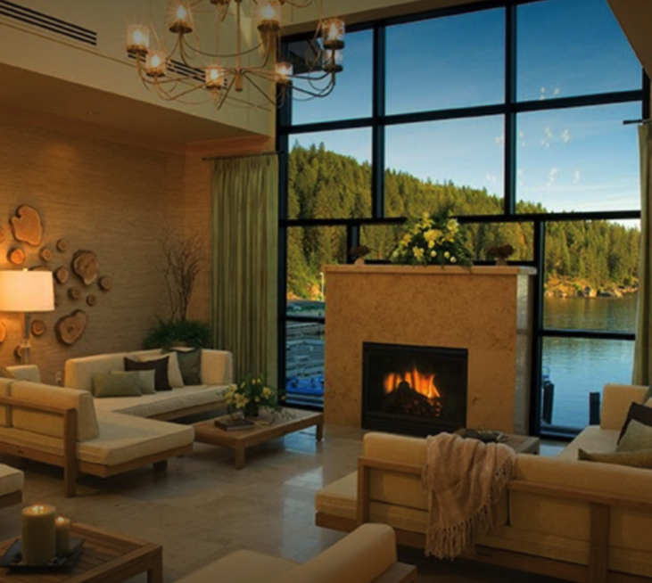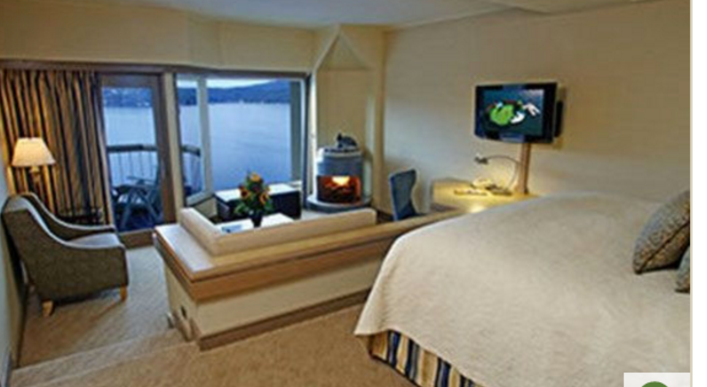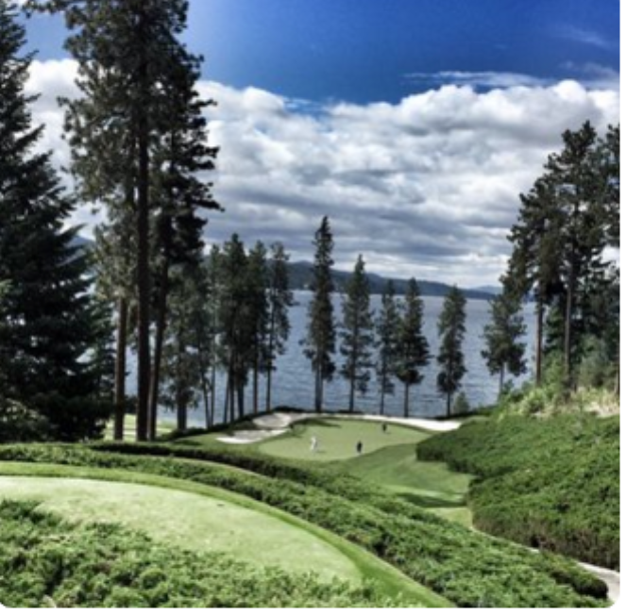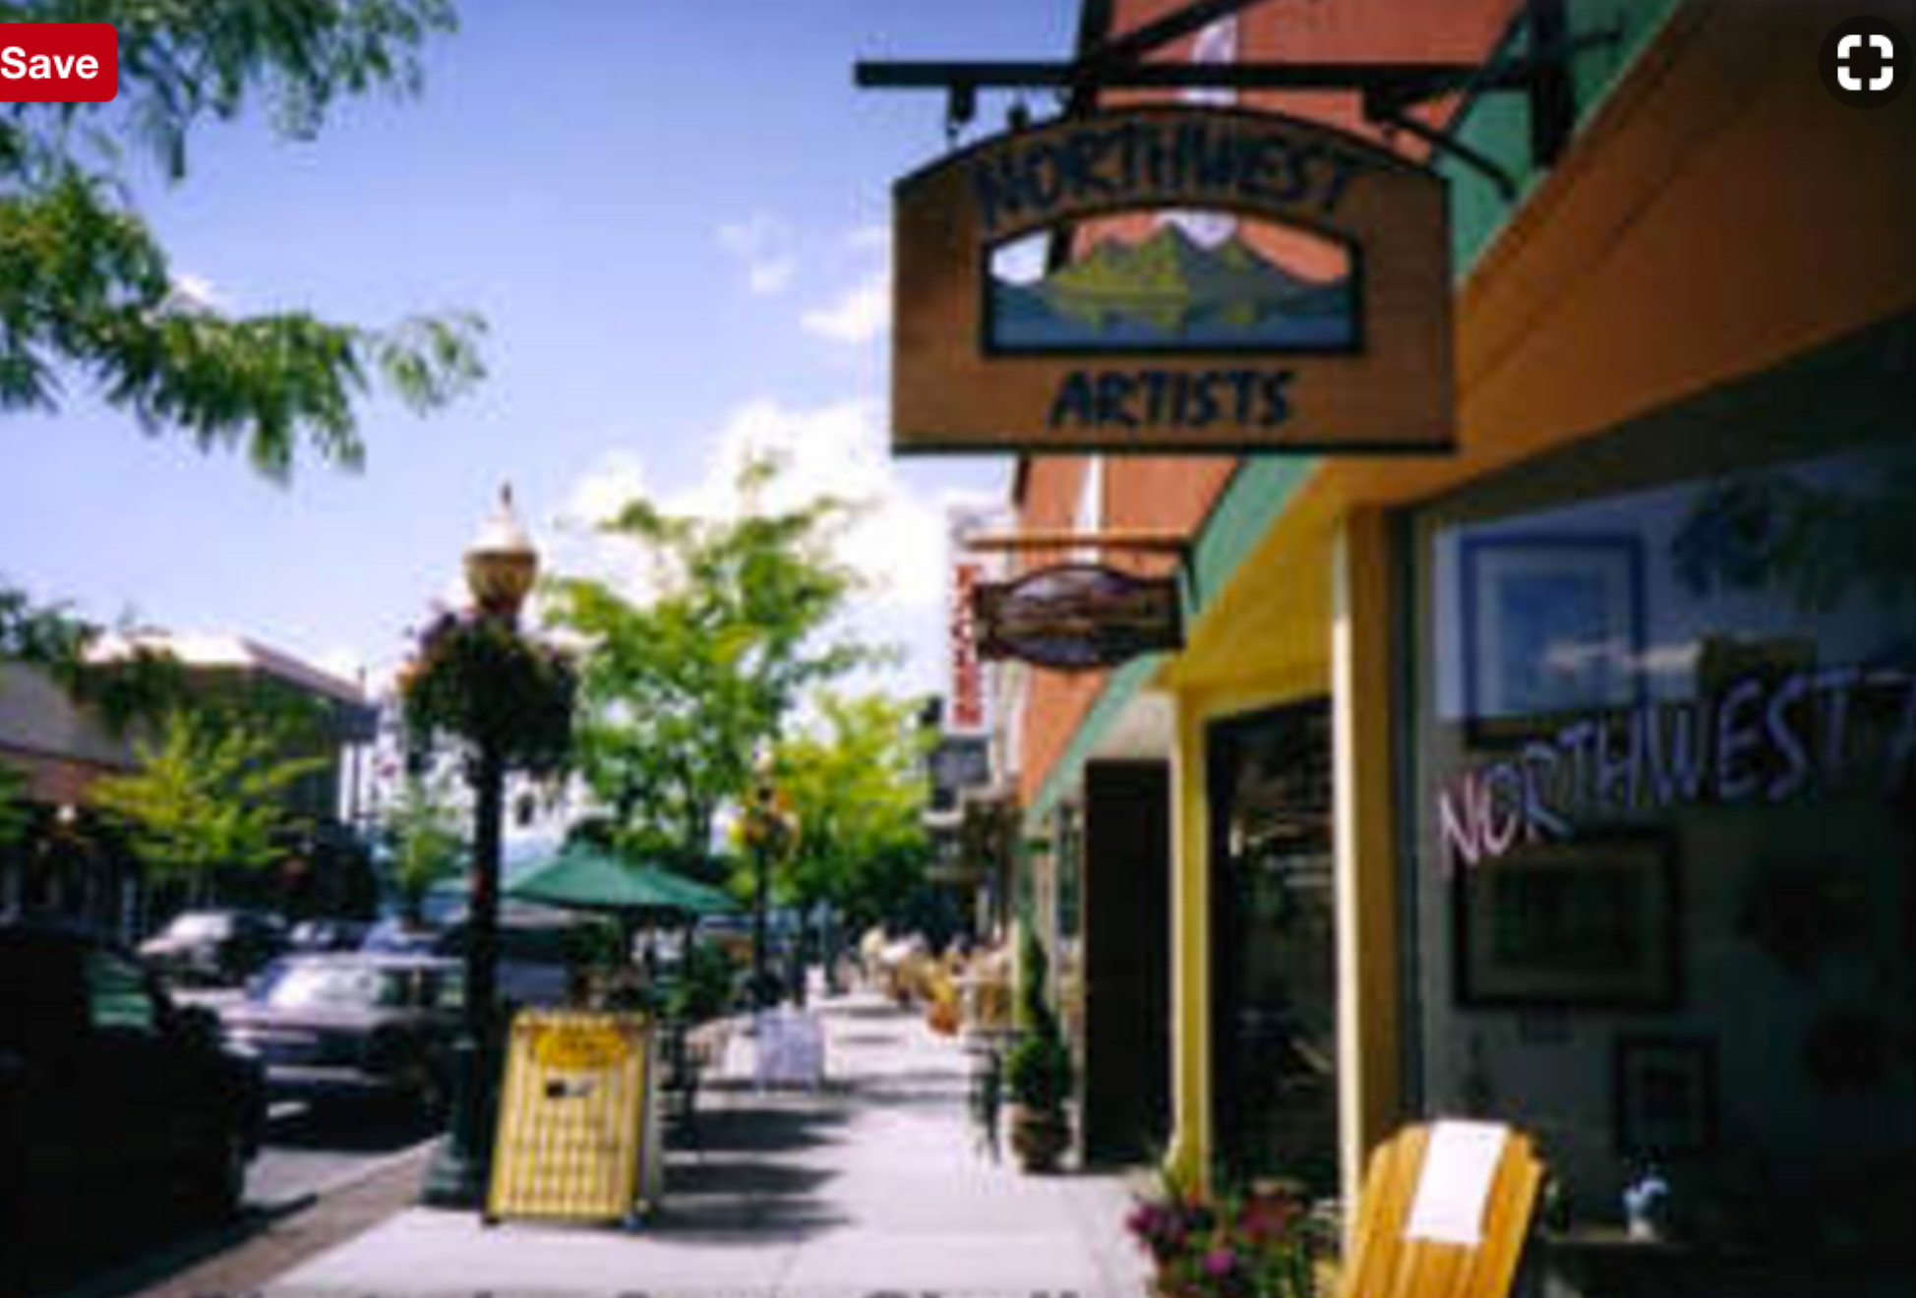

Info: Thelma de Souza 415-269-0089 Thelma.pcoos@gmail.com WWW.PCOOS.online.org

